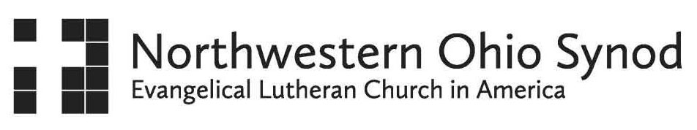

**Letter of Agreement for a Synodically Authorized Minister Placement**

In keeping with the policies and practices of the Northwestern Ohio Synod, Evangelical Lutheran Church in America, and in order to set forth clearly the agreement for pastoral leadership by a Synodically Authorized Minister (SAM), we adopt these guidelines for the working relationship between:

_________________, SAM

and

______________________ Lutheran Church

Anticipated Dates of contract: ____________________________

The SAM will:

* Endeavor to give spiritual guidance to the congregation and uphold it in prayer.
* Provide Sunday worship leadership and preaching, including presiding over the Sacraments (as approved by the Bishop)
* Work together with the Church Council
* Focus on discipleship teaching and bible study
* Shepherd member needs, as requested or needed – hospital calls, funerals, grief work, in tandem with the parish’s outreach ministry team(s)
* Provide regular office hours
* Participate in congregational council meetings

The congregation will:

* Uphold the SAM in prayer and accord love, respect, and good will toward him/her
* Work together with the SAM in the leadership capacities mutually agreed upon
* Compensate the SAM at an agreed upon rate, as well as, pay mileage at the standard IRS rate.

Together the congregation and SAM will:

* Work towards healthy ministry
* Deal with shifts in leadership that inevitably occurs in times of transition
* Reflect on the congregation’s relationship with the Synod and the Evangelical Lutheran Church in America and the mutual responsibilities involved
* Discover the congregation’s unique identity and its hopes and dreams for the future as centered in the Gospel of Jesus Christ
* Develop a commitment to new ministry and leadership to which God is calling the congregation.

This agreement may be amended or extended upon the mutual agreement of the congregation council and the SAM, after consultation with the Director of Leadership Development for Congregational Care of this synod, by written addendum attached hereto.

We, the undersigned, accept the terms of this agreement:

_________________________________________________ _______________________________

Congregation Council President Date

_________________________________________________ _______________________________

Synodically Authorized Minister Date