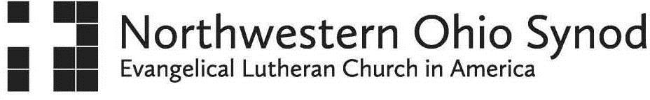
Office of the Bishop 621 Bright Road
Findlay, Ohio 45840-6987
Phone: 419.423.3664
www.nwos-elca.org

COVENANT OF SEPARATION – ________________(Pastor)
Pastor _______________,
On behalf of Bishop ________________, the _________ Conference and this Synod, I extend to you many blessings and prayers upon your resignation from _______ (Church), ___________ (City) and your impending new call.
This Covenant of Separation is designed to help guide changes in the relationship between you and the __________ (Church) parish upon your departure from this ministry. It is intended to strengthen accountability for you and the parish through establishing a safe and healthy relationship and ministerial boundaries.
Upon your departure, healthy boundaries include not participating in any ministerial functions nor responding to requests for, or engaging in, any hospital or ministerial visitation related to the parish at any time after your official resignation date. In essence, upon your last day with the ministry, you no longer are able to serve as pastor or staff for this parish and do not have the authority to make such commitments. It is important for all members of the parish to understand the importance of this agreement. While it is hard to minimize some relationships, it is absolutely essential that any future contacts be on a friendly basis and we suggest that for an extended period of time, these contacts be limited as well. These Covenant boundaries certainly affirm your past service but are important so that the parish can bond with and build a trusting relationship with new pastoral leaders who will provide the necessary ministry functions. In addition, according to the constitution of the Northwestern Ohio Synod of the ELCA:
ϯS14.19. Ministers of Word and Sacrament shall respect the integrity of the ministry of congregations which they do not serve and shall not exercise ministerial functions therein unless invited to do so by the pastor, or if there is no duly called pastor, then by the interim pastor in consultation with the Congregation Council.
Again, if invited to participate in a ministerial role by a member of the parish, you are not at liberty to accept the invitation. The Synod will work with the parish to ensure that appropriate care is received throughout the transition process. We also encourage that you, as the resigning Pastor, not receive or entertain negative comments or participate in conversations or activities which might undermine the parish’s ministry, programs or people. We also expect that all records are left in good order and any financial obligations are respected.

This Covenant is offered to you and the people of _________(Church), __________(City) for the sole purpose of strengthening mission and ministry in the future. It acknowledges deep gratitude for the past years of your significant ministry together and is built on Christ’s hope for this parish as it moves ahead in mission and ministry.

We ask for the designated signatures below as a promise that both parties agree to uphold this Covenant of Separation for the health and welfare of this congregation and pastor.

Blessings and Peace,
Sherry L. Krieger – Director of Leadership Development for Congregational Care, NWOS-ELCA
, Date , Date
Church Council President Pastor

And the one who was seated on the throne said, "See, I am making all things new." - Revelation 21:5a

